Internet Of Things!
iot temperature monitoring using arduino.

IoT System Design Project Report

Module: CST2701 – Internet of Things System Design
Student: Sumaya Mahdi Ali ,
Project Title: IoT Temperature Monitoring System using Arduino.

1. Introduction

The internet of things (IoT) is the most innovative technologies in modern computing, it connects physical devices to the internet which allow them to sense, collect and share data automatically.

This report presents a simple but practical IoT system- a temperature monitoring and alert system created using Arduino Uno, a TMP36 temperature sensor, and an LED indicator. The purpose of this project is to demonstrate how IOT systems can detect real world changes (in this case, temperature) and respond automatically without human input.

The project works by detecting ambient temperature through the TMP36 sensor. When the temperature rises above a predefined threshold (e.g., 27°C), the Arduino sends a signal to turn on the LED light. When the temperature drops back below that level, the LED turns off. This process mimics how IoT systems function in real applications such as healthcare monitoring.

2. Research and Background

IoT systems rely on interconnected devices that gather, process and exchange information, which includes sensors, microcontrollers which are connected through wired or wireless networks. According to Cisco (2023), there are billions of IoT devices worldwide that collect and analyse data in real time to support industries like agriculture and transportation.

- Temperature monitoring is a fundamental application of IoT. For example:
- In healthcare, IoT temperature sensors can monitor patient body temperatures remotely.
- In agriculture, farmers use temperature and humidity sensors to control greenhouse conditions.
- In smart homes, thermostats automatically adjust heating and cooling based on temperature readings.

This project represents a small-scale version of those systems, simply showing how an Arduino microcontroller can collect data from a temperature sensor and automatically react to it, Arduino is widely use in IoT projects because its affordable and easy to program. By using a TMP36 sensor and an LED as a visual alert, the system demonstrates the core IOT process: sensing → processing →Acting.
2.1 Major ICT Trends Impacting IoT

5G Technology

5G enables extremely fast data transfer, supports millions of devices, and allows lower latency. This enhances IoT performance, especially in applications needing real-time monitoring.

Artificial Intelligence (AI)

AI improves IoT systems by enabling pattern recognition, anomaly detection, and automated decision-making from sensor data.

Edge and Fog Computing

Instead of sending all data to the cloud, edge computing processes data locally, reducing delays, improving reliability, and increasing efficiency.

Blockchain

Blockchain provides secure, tamper-proof records of device activity and ensures trusted communication between IoT devices.

2.2 Influence of These Trends on IoT

These trends improve IoT systems by supporting:
• Scalability (support for more devices)
• Automation (systems respond without human intervention)
• Security (better data protection)
• Real-time analytics (immediate decision-making)

⸻

2.3 Opportunities and Challenges of IoT

Opportunities
• Real-time monitoring
• Cost reduction
• Automation and efficiency
• Predictive analytics

Challenges
• Cybersecurity vulnerabilities
• Privacy concerns
• Interoperability between different devices
• Dependence on stable network connectivity

⸻

2.4 M2M vs IoT and Case Study

Machine-to-Machine (M2M)
• Devices communicate directly
• Limited scalability
• No cloud intelligence

Internet of Things (IoT)
• Uses internet/cloud
• Remote access
• Smart analysis using AI
• Highly scalable

Case Study: Smart Thermostats

Smart home thermostats monitor temperature, learn user behaviour, and adjust heating automatically. This demonstrates IoT’s advantage over M2M because of remote access, cloud integration, and data analytics.

3. System Design and Architecture

3.1 Hardware Components
The project uses the following components:
- Arduino Uno R3 – acts as the microcontroller to process sensor data.
- TMP36 – reads the ambient temperature and outputs an analog voltage.
- LED light- turns on when temperature exceeds a certain threshold.
- Resistor (220Ω) -limits current to protect the LED.
- Jumper wires and breadboard – for circuit connections.

3.2 Circuit Connection
The circuit was designed and tested using Tinker card, an online electronics stimulation platform. The connections were made as follows:
- The TMP36 sensor has three pins:
- VCC 5V - on Arduino
- GND- Gnd on Arduino
- Vout- Analog pin A0
- The LED has two legs:
- Anode (long leg) – Digital pin 8 through a 220 Ω resistor
- Cathode (short leg) - GND

This set up allows Arduino to read temperature values through the sensor and send a signal to the LED when conditions meet the threshold.

Figure 1: Tinker cad Circuit Diagram (TMP36 + LED + Arduino)

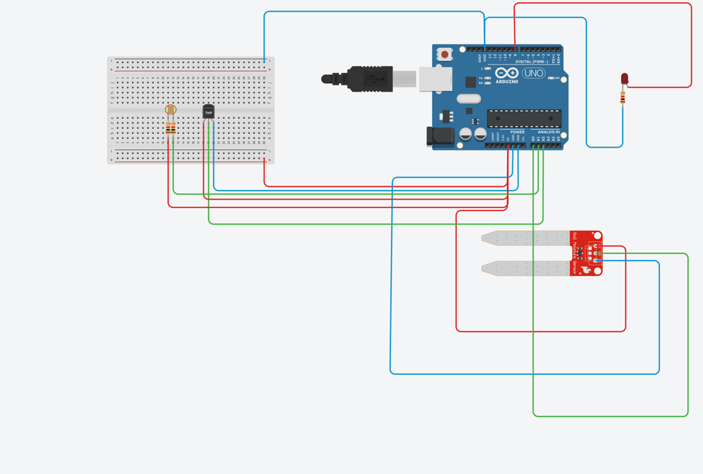

Figure 2: Arduino Code Window (Tinker card Stimulation)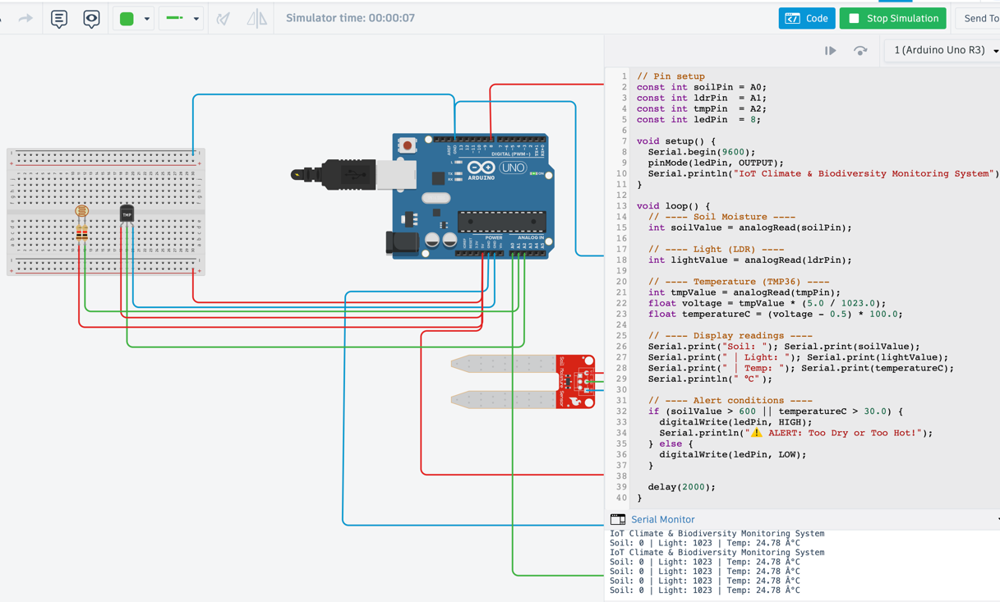
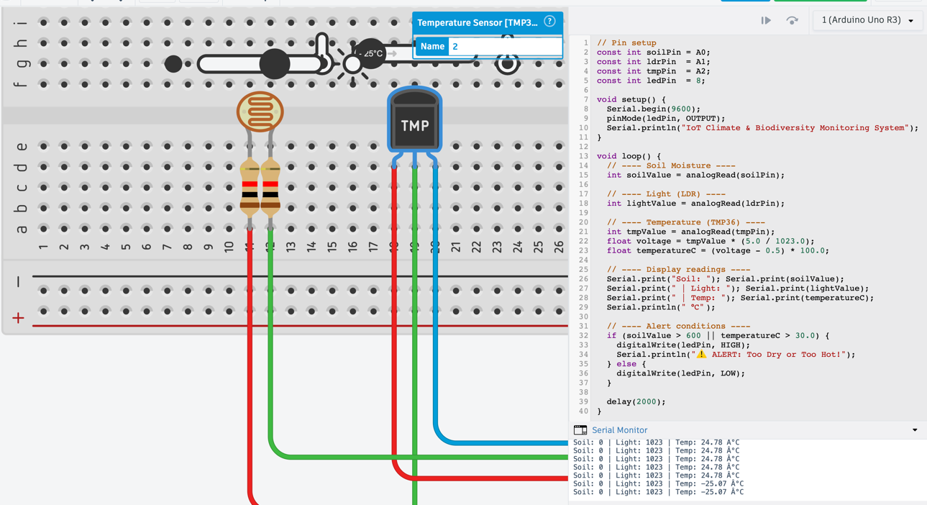

3.3 Software and Code Explanation
The Arduino code was written in three Arduino IDE and stimulated in Tinker card. The program reads the following tasks:

- Reads the analog temperature value from the TMP36 sensor.
- Converts the voltage reading into a temperature in Celsius.
- Checks if the temperature exceeds a threshold 28°C).
- Turns on the LED if it does and turns it off if it does not.

Sample Arduino Code:

const int sensorPin = A0;
const int ledPin = 8;
float temperature = 0;

void setup() {
pinMode(ledPin, OUTPUT);
Serial.begin(9600);
}

void loop() {
int sensorValue = analogRead(sensorPin);
float voltage = (sensorValue / 1024.0) * 5.0;
temperature = (voltage - 0.5) * 100.0;

Serial.print("Temperature: ");
Serial.print(temperature);
Serial.println(" °C");

if (temperature > 28.0) {
digitalWrite(ledPin, HIGH);
} else {
digitalWrite(ledPin, LOW);
}
delay(1000);
}

This code continuously monitors the temperature. When it detects a reading above 28°C, it activates the LED. The system also displays the current temperature in the Serial Monitor for debugging and observation.

4. Testing and Results
The system was tested in Tinkercad to verify correct behaviour. The TMP36 sensor readings were monitored through the Serial Monitor. As the simulated temperature increased, the calculated Celsius value rose accordingly. When the temperature exceeded 28°C, the LED turned ON. When it fell below the threshold, the LED turned OFF.

These results confirm that the microcontroller successfully reads sensor data, processes it, and performs an automated response consistently.

5. Discussion and Improvements
This project demonstrates key IoT principles: collecting sensor data, processing it, and performing automated actions. Although simple, it mirrors systems like smart thermostats and healthcare temperature monitors.

Advantages:
• Low-cost and beginner friendly components.
• Real-time monitoring with instant reaction.
• Scalable system design.
• Serial Monitor provides easy debugging.

Disadvantages:
• TMP36 has limited temperature accuracy.
• No wireless/cloud communication.
• System is wired.
• Uses a single fixed threshold.

Possible Improvements:
• Add WiFi (ESP8266/ESP32) for cloud dashboards.
• Use a more accurate digital temperature sensor.
• Add SD card or cloud data logging.
• Add buzzer or mobile notifications.
• Build a web or mobile interface.

6. Conclusion
This project successfully demonstrates a functional IoT temperature monitoring system using Arduino. The TMP36 sensor, LED indicator and programmed logic allow the device to read temperature changes and respond automatically when the threshold is reached.

Although simple, the design reflects real IoT systems and can be expanded into more advanced applications such as smart climate control, healthcare monitoring, and automation.

7. References
Arduino Official Website. (2024). Learn Arduino Basics. https://www.arduino.cc/
Autodesk Tinkercad. (2024). Circuits and Simulation
https://www.tinkercad.com/
Cisco. (2023). Internet of Things Explained. Cisco Networking Academy.
ResearchGate. (2023). IoT in Healthcare Monitoring Systems.

